Table of Contents

1 Attack Guidance Matrix (AGM) Integration with MSDL 1
1.1 Background 1
2 Technical Approach 1
2.1 References 1
2.2 Schema Extensions to MSDL 1
2.2.1 AGM 1
2.2.2 Target 3
2.2.3 Ammunition 5
2.2.4 WeaponTargetPairing 6
2.3 Open Issues and Questions 8
2.3.1 Target Sheets 8
2.3.2 TargetValueType 9
2.3.3 AFATDS Target Type/Category 10
2.3.4 Hit Moving Targets 10
2.3.5 Max Range Limit 10
2.3.6 Munition Type 10
2.3.7 LAM Modifier 11
2.3.8 Effect 11

Table of Figures

Figure 1: AGM Base Element 1
Figure 2: AGM Element in MSDL 2
Figure 3: Target Element 3
Figure 4: Target Element in MSDL 4
Figure 5: Ammunition Element 5
Figure 6: AmmunitionStatus Element in MSDL 5
Figure 7: Ammunition Element in MSDL 6
Figure 8: WeaponTargetParing Element 6
Figure 9: Size of Enemy Element in MSDL 7
Figure 10: Weapon Target Pairing Element in MSDL 8
Figure 11: Target Sheet from FM 6-20-10 9
Figure 12: Target Spread Sheet from FM 6-20-10 9

Attack Guidance Matrix (AGM) Integration with MSDL

Background
In the past MSDL development/extensions have focused on BN and below. To support BN and above, MSDL needs to provide top-down planning detail. The Attack Guidance Matrix is an example of a top down planning product that bottom up planning as well as execution (simulation) depends upon.

Technical Approach
This approach presents the current AGM implementation, and makes recommendations on how to integrate with MSDL. The approach focuses on the complex elements and leaves the specifics to be identified in the MSDL schema once consensus to the approach has been reached.

References
- MIL STD 2525B Common Warfighting Symbology
- FM 6-20-10 The Targeting Process
- FM 6-71 Fire Support for the Combined Arms Commander Sept 29th, 1994
- FM 6-20-40 Fire Support For The Heavy Brigade Operations
- NEC2AGM.xsd – MATREX provided schema for the attack guidance matrix (starting point)
- fom_v1.0_10MAY2005.omd – MATRIX provided FOM including AGM FOM data.

Schema Extensions to MSDL
This technical approach outlines the AGM entity relationship of AGM elements and attributes to MSDL elements.

AGM
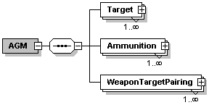
Figure 1: AGM Base Element
Type: Complex Element

Attributes
- Name – Replace with the MSDL Name element.
- Sender – Drop from use in MSDL. Suggest this be maintained on the application side.
- Receiver – Drop from use in MSDL. Suggest this be maintained on the application side.
- Mission – Drop in favor of the Mission statement in the MSDL OPORD Summary.
- DTG – Replace with the MSDL DateTimeGroup field taken from MIL STD 2525B.

Subordinate Elements
- Target – Group in MSDL under a new element named TargetList.
- Ammunition – Group in MSDL under a new element named Munitions.
- WeaponTargetPairing – Group in MSDL as WeaponTargetPair under a new element named WeaponTagetPairing.

MSDL Recommendation
Make this subordinate to the MSDL COA element and group/wrap the subordinate elements into common bins as described above.
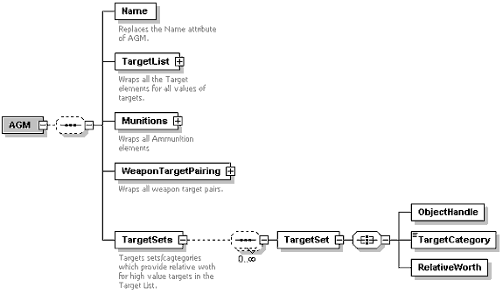
Figure 2: AGM Element in MSDL
For details on the TargetSets refer the section 2.2.2 on Target.

Target
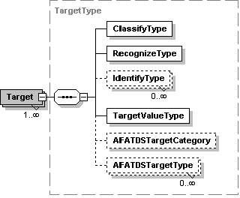
Figure 3: Target Element
Type: Complex Element

Attributes
- Key – Replace with the MSDL element of ObjectHandle.
- Priority – Keep and make an MSDL element.
- Name – Replace with the MSDL element of “Name”

Subordinate Elements
- ClassifyType – Suggest we use the 2525B SymbolID to classify the targets by functional areas in concert with the Mobility Indicator. MIL STD 2525B does not specifically handle the “Uknown”, “Individual”, or “Other” enumerations.
- RecognizeType – Suggest we use the 2525B SymbolID to classify the targets. This provides more specificity than ClassifyType, but the mobility indicator does not change.
- IdentifyType – Suggest we use the 2525B SymbolID to classify the targets. This provides more specificity than RecognizeType, but the mobility indicator does not change.
- TargetValueType – Open item in TargetValueType.
- AFATDSTargetCategory – Open item in AFATDS Target Type/Category.
- AFATDSTargetType – Open item in AFATDS Target Type/Category.

MSDL Recommendation
Move Target under TargetList and modify the Attributes of Key and Priority to become MSDL elements as outlined above.
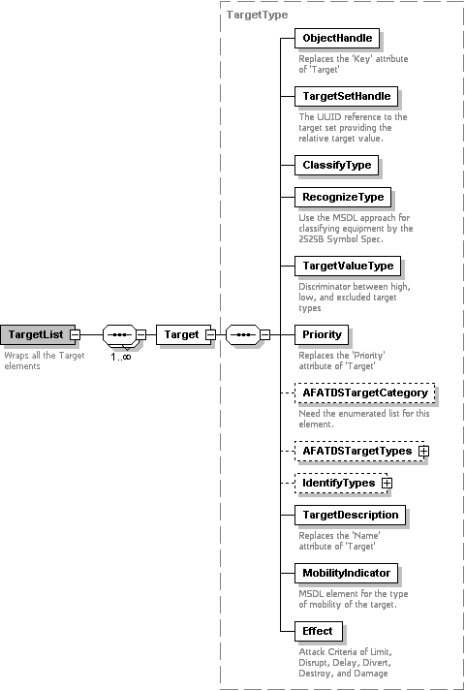
Figure 4: Target Element in MSDL
Add a new TargetSets element to the AGM as outlined above.

Ammunition
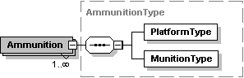
Figure 5: Ammunition Element
Type: Complex Element

Attributes
- Key – Replace with the MSDL ObjectHandle element.
- MaxRange – Drop or leave as a parametric attribute.
- MaxRangeLimit – Open item Max Range Limit
- MinRange – Drop or leave as a parametric attribute.
- Allocation – Keep as is.
- BasicLoadOnHand – Keep as is.
- PercentRemainingAfterPhaseI – Replace with the Ammunition Status complex element.

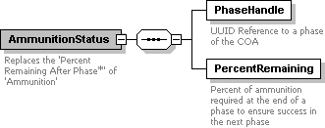
Figure 6: AmmunitionStatus Element in MSDL
- PercentRemainingAfterPhaseII – Replace with the Ammunition Status complex element.
- PercentRemainingAfterPhaseIII – Replace with the Ammunition Status complex element.
- PercentRemainingAfterPhaseIV – Replace with the Ammunition Status complex element.
- PercentRemainingAfterPhaseV – Replace with the Ammunition Status complex element.
- HitMovingTargets – Open item in Hit Moving Targets.

Subordinate Elements
- PlatformType – Suggest we use the 2525B SymbolID to classify the targets.
- MunitionType – Open item in Munition Type.

MSDL Recommendation
Move Ammunition under Munitions and modify the Attributes to become MSDL elements as outlined above. Change the Ammunition Status to be a complex type which references the specific MSDL Phase.
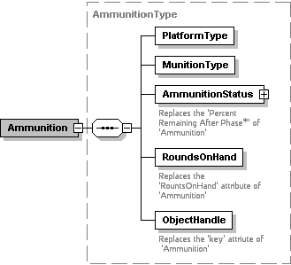
Figure 7: Ammunition Element in MSDL

WeaponTargetPairing
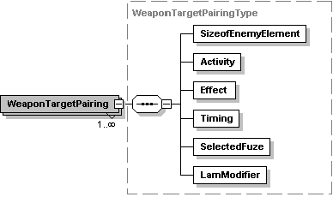
Figure 8: WeaponTargetParing Element
Type: Complex Element

Attributes
- TargetKey – Replace with the TargetHandle element as a UUID Reference to the target’s ObjectHandle.
- AmmunitionKey – Replace with the AmmunitionHandle element as a UUID Reference to the ammunition’s ObjectHandle.
- Priority – Use the AGM definition.
- RequiredTLE – Use the AGM definition for Target Location Error but change to an element.
- RoundsToFire – Use the AGM definition but change to an element.

Subordinate Elements
- SizeOfEnemyElement – Replace with the MSDE EnemySize element, or use the EnemySize data type and keep the AGM name.

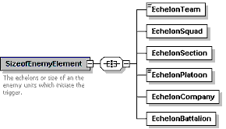
Figure 9: Size of Enemy Element in MSDL
The concept here is if a specific echelon is specified, but recognized as being different, should the target still be attacked? This structure enables MSDL to explicitly specify which echelons of a given target should be attacked.
- Activity – Both MC2 and FM 6-20-10 define this as Moving and Stationary. MCT includes All (or both?) in addition.
- Effect – Use the FM definition of Destroy, Divert, Disrupt, and Delay. Open item in Effect.
- Timing – The current implementation matches the doctrine (FM 6-20-10)
  - “As Acquired", "Immediate", or "Planned”
- SelectedFuze – Need more detail. The FOM implementation looks questionable. It includes both fuse type and delay setting in one enumeration. Suggest we split into FuseType and Delay.
- LamModifier – Open item in LAM Modifier.

MSDL Recommendation
Rename WeaponTargetParing as WeaponTargetPair and move it under WeapoinTargetParing. Extend SizeOfEnemyElement to match the MSDL element EnemySize. Make selected fuse a complex element of fuse type and delay..
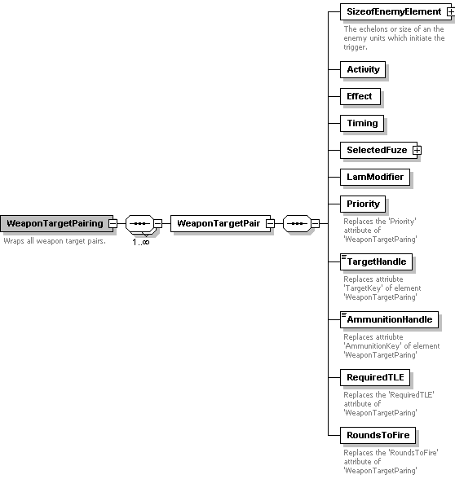
Figure 10: Weapon Target Pairing Element in MSDL

Open Issues and Questions

Target Sheets
The AGM leads to the generation of “Target Sheets”, however there is information on these sheets we have not yet accounted for:

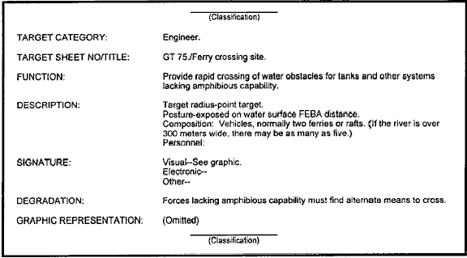
Figure 11: Target Sheet from FM 6-20-10

TargetValueType
TargetValueType – In the FM, target values are specified are relative worth. Their example appears to be 0-8, where the number 8 represents the greatest value. I believe MC2 is expecting something like High, Medium, Low, and Excluded. We need to confirm this assumption. I believe High becomes the discriminator of what is represented in the high value target list. Within that set the Relative Worth discriminates between high value targets. This means we need a new element of TargetSetHandle to reference which Target Set a specific High value target belongs to. This field of data may actually be the Target Category in the Target Set. Reference the figure below from FM 6-20-10:

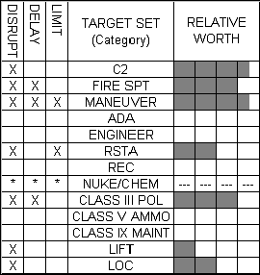
Figure 12: Target Spread Sheet from FM 6-20-10

If we can agree to these assumptions, a new AGM sub-element needs to be added (TargetSets):

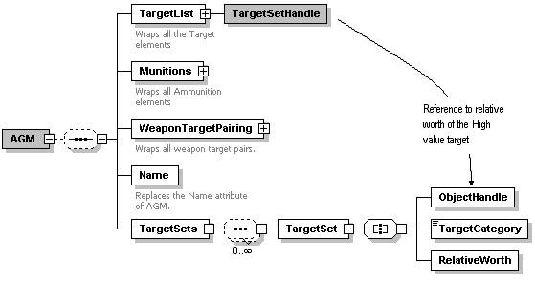
The Target Category is an enumerated category taken from Appendix A of FM 6-20-10 on page A-13. See the Target Spread Sheet in Figure 4 about for the specific (13) values.
.
Note: The other TagetList elements were omitted from the figure for clarity.

AFATDS Target Type/Category
AFATDSTargetCategory – Need the AFATDS Target Categories. Using AFATDS categories is risky as being application dependent. MSDL is intended to be an international standard. Does this target category match the target category of the Target Set in FM 6-20-10?

AFATDSTargetType – Need the AFATDS Target Types. Suggest we use the 2525B Symbol ID to classify the target types. Using AFATDS types is risky as being application dependent. MSDL is intended to be an international standard.

Hit Moving Targets
HitMovingTargets –This appears to reflect what the weapon/ammunition is capable of engaging (moving and/or stationary targets)

Max Range Limit
MaxRangeLimit – Drop or leave as a parametric attribute. Need to determine if this value varies by mission (not entirely representative of parametric data).

Munition Type
MunitionType – Need to find a good standard for this. AMSAA may have one.

LAM Modifier
LamModifier – Need more detail on this. Land Air Mobility Modifier? Can we use the 2525B Symbol ID or Hierarchy in combination with the Mobility Indicator for this?

Effect
Effect – Used in FM 6-20-10 is defined as Destroy, Divert, Disrupt, and Delay. Need to verify the FM 6-20-10 definition is a proper match. By FM 6-20-10 the effect of Suppress, Neutralize, Destroy and Harass are attack criteria and should live in the Target List not the Weapon Target Pair. The “effect of attack” is defined as Limit, Disrupt, Delay, Divert, Destroy, and Damage. Reference page 1-1 of FM 6-20-10. Note: The FM cautions against this confusion.

Targets
Targets - By FM 6-20-10 are facilities, units, and other organizations (resources & capabilities the enemy can least afford to loose). We seem to be are concentrating on platforms/weapons alone. Does the MC2 deal with units, installations, supply elements, etc?

Named/Targeted Areas of Interest
Named Area of Interest (NAI) - An NAI is an area along an avenue of approach or mobility corridor where enemy activity (or-lack of it) will confirm or deny a COA. So high value targets are monitored in NAIs. When a high value target becomes a priority it transitions to a high priority target within a TAI. Does the MC2 link targets with NAIs and/or TAIs.

